MS Civil Rights Template for Lesson 1: Civil Rights and Me
**Additional slides as needed

Objectives  Students will be able to...  - Use communication and social skills to positively interact with others by referring to shared agreements  - Define Safe & Respectful Learning Environment  - Demonstrate ways to get help and support if they are concerned about their safety or rights  - Understand the importance of reporting | Materials Needed  - Sticky notes (1 per group)  - Markers  - Pencils  - Pad of Poster Paper  - Optional- Handout “Vocabulary Fill in the blank”- make 1 copy per student.  - Optional- Handout for Discussion “What Youth Can Do if They Are Being Bullied”

Time | Description and Talking Points | PPT Slides
1  minute | Objectives- Read objectives on the slide or have student's popcorn read them | 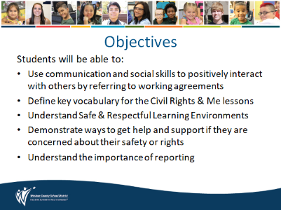
2  minutes | Working Agreements -  Teacher- read agreements or have student's popcorn read the agreements; discuss and clarify. | 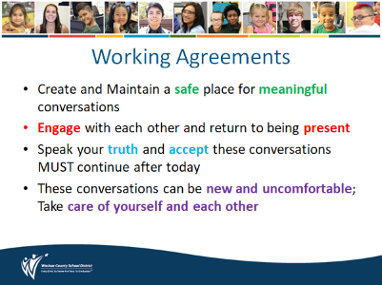
3  minutes | Warm-up:  Teacher read aloud the quote-  “Change the belief, and the thinking changes. Change the thinking, and the action changes. Change the action, and the result changes.” - John Assaraf  Ask student to Think-Turn-Tell to give an example about how this might apply at school. Share with their group or out loud or write in the chat if delivering online. | 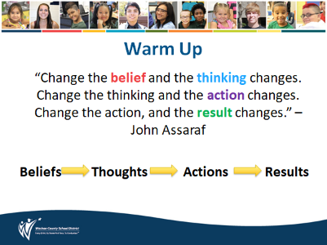
5 minutes  5 minutes | Introduce Key Vocabulary:  Teacher- Introduce key vocabulary words (slide 5) and review definitions on slides 6, 7, 8  (Optional Activity In-Person)- Make copies of Lesson 1 handout -Vocabulary Fill in the blank (student copy only). Students can follow along and fill in the blank with the Lesson 1 as the teacher reviews the definitions.  Vocabulary words will be further explored in Civil Rights & Me Lessons 2, 3, 4 | 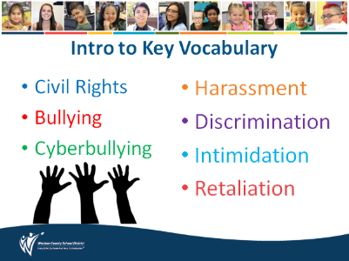  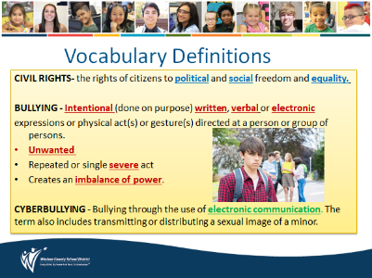  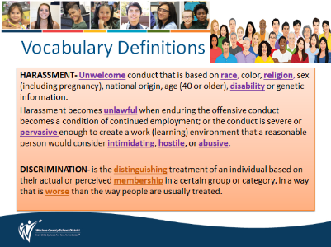  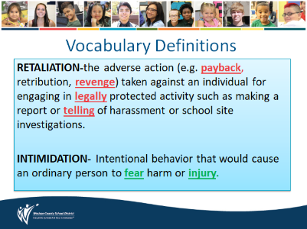
2  minutes | Define Safe & Respectful Learning Environments and its principles  Teacher- Read aloud slides 9 & 10. Clarify any questions students may have. | 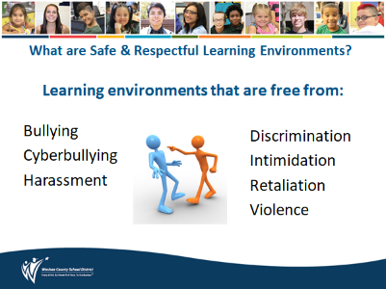  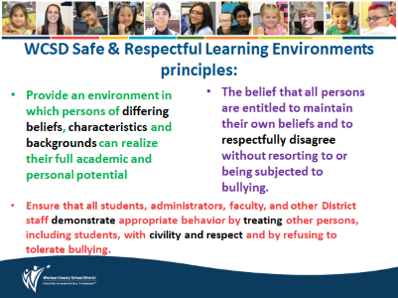
5  Minutes  5  minutes | Think-Turn-Tell Activity  Teacher- What do you do if your or someone else’s rights have been violated or you are worried about someone’s safety?  Tap into students’ prior knowledge about getting help. Have a class or (group) discussion about what to do if their rights have been violated or they are worried about someone's safety. (Slides 14-19 will address getting help)  Optional Activity: Have students make a group poster about what to do if their rights have been violated or they are worried about someone’s safety.  *Add on to the poster at the end of the lesson 1 after all of the information has been shared.  Have them work in groups to make a group poster answering the following questions:  - Who can they talk to?  - What should they report?  - How can they report the information? or  - Where can they report the information? | 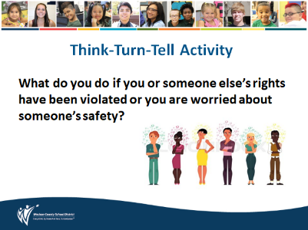
8  minutes | Video & Class Discussion:  Teacher- Emphasize to students why it’s important to understand the difference between reporting (getting help/advocating) and snitching. The term snitching is used to silence others, so they don’t get help. Reporting/Telling is a proactive approach before the situation gets worse.  Reframe getting help to becoming an advocate or self-advocate. An advocate helps others get what they need. A self-advocate communicates their own needs.  How does getting help build positive school climates?  Embrace these important points  • No one ever deserves to be bullied  • You have the right to ask for help to stop the behavior  • Your opinion about what to do is important  • You don’t have to go through the bullying experience alone  Play video  - After video discussion - tie back into original quote ““Change the belief, and the thinking changes. Change the thinking, and the action changes. Change the action, and the result changes.” - John Assaraf  Show Comparison Chart Reporting vs. Snitching  - Stress the importance of getting help  - Use the What Youth Can Do If They Are Being Bullied- Q&A handout to help guide discussion on getting help | 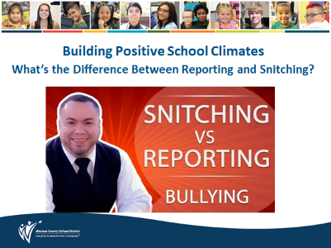  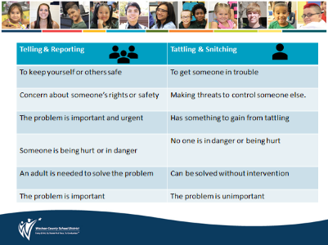
5  minutes | Class Discussion  Teacher- Remind students of the importance of talking with a trusted adult and use of SafeVoice for anonymous reporting and helping others. An advocate helps others get what they need. A self-advocate communicates their own needs.  Review SafeVoice information in slides 15, 16, 17, 18 | 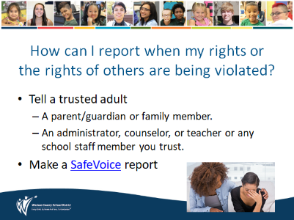
5  minutes | Review of SafeVoice  Teacher make note of:  - SafeVoice is for safety of self and others  - Anonymous reporting via phone, website, or app  - Report incidences related to: bullying/cyberbullying, suicidal thoughts or self-harm, sexual harassment, substance abuse, violence or weapons.  - SafeVoice information is on the back of student ID badges | 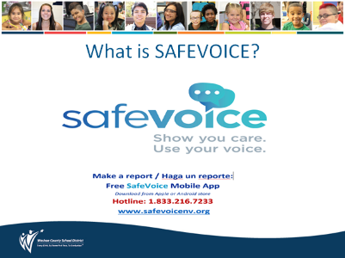  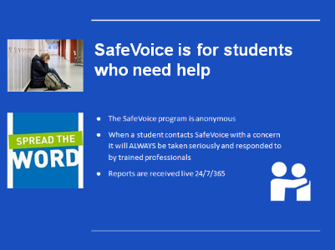  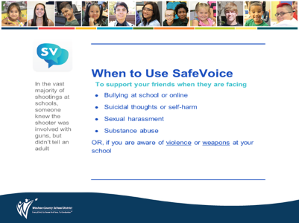  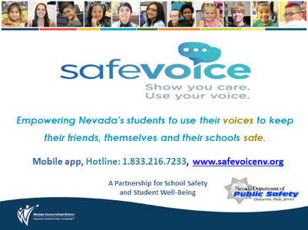
1 minute | Other Ways to Report  Teacher- Review these 2 other ways to file a complaint, click on blue hyperlinks to view forms | 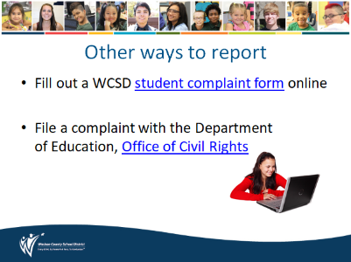
5  minutes | Wrap-up  Positive Post-its  Teacher- lead a quick discussion on how being an advocate and getting help creates healthy school climates & culture.  Students- write down 3 positive outcomes on 3 different sticky notes related to advocacy, taking action and getting help – put up on posters around the room. Tie back into quote- “Change the action, and the result changes.”  Poster Titles:  - Self  - School  - Community  *Teacher can read responses aloud when done or students can take a walk around the room and look at the posters. | 